# Introduction

Music should be fun for everyone, regardless of your age, place, or music choice. This created BetterMusic. An app that is a digital music streaming application which gives you access to an unlimited number of songs from artists around the world.

The main purpose of BetterMusic is to give users the right to listen to music, anywhere, anytime and for free. The purpose is to give users accessibility and usability in the sense of high standard design and interaction between MDI.

# User story: Describe the different user stories & explain how users will benefit from your app

The User stories for Better Music are describe functionality from users' perspectives, which are desired and how they can be met.

User stories are described with a clear illustration of what kind of what the persona wants and how it can be met. The method that has been used for the creation of different types of user stories is As X I want Y to achive Z.

|  |  |  |  |
| --- | --- | --- | --- |
| **Id** | **Author** | **I [want to]** | **[so that i can achieve...]** |
| **1** | **Music enthusiast** | I want to be able to login to my account once | So that I don’t have to relog every time I open the app |
| **2** | **Music enthusiast** | I want to be able to see the top Artists | so that I can listen to which artist is trending |
| **3** | **Music enthusiast** | I want to be able to see the top Albums | so that I can listen to which Album is trending |
| **4** | **Music enthusiast** | I want to be able to search a song | So that I can listen to a certain song. |
| **5** | **Music enthusiast** | I want to be able to play and pause the selected song | So that I can decide when to play and pause my music. |
| **6** | **Music enthusiast** | I want to be able to fast forward and backward on a slider for my selected song. | So that I can choose where on the song I want to listen. |
| **7** | **A long distance runner** | I want to be able to play music quickly after the app has started | So that I can continue with my running |

# Describe technical features such as web service connections, databases, sensors, camera etc.

The structure of my application/project is wide. My project uses a WEBAPI 2 as an API that is connected to a local *SQL-sever management*.

### Database - SQL server Managment

Since the main purpose of the API and database was to provide smaller information to the application, I decided to keep the database table small and simple.

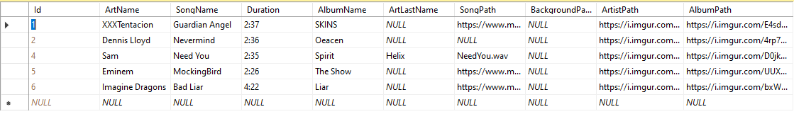

For future development of the project, I will update the database with relations between multiple tables by dividing properties which has relations to each other into new tables and connect the tables by foreign keys. This so there will be more of a logical structure of data and models for future work and expansions off the app. This dividing of data into tables will be done by following the *form of normalization* ( Padron-McCarthy & Risch , 2018)

### WEBAPI2 – Visual studio

For my API I used WEBAPI2 from visual studio (.net framework) with an MVC concept. Here is nothing out of the ordinary created. I connected my Database to the solution and build an Entity framework. The controllers on this project are all scaffolded from the design table of the Database.

Something worth mentioning is that I had a lot of problems with connection between my Emulator and API. Since the emulator has an own IP-adress and my computer has anotherone, upon using localhost:(port)/Api/controller, in the react native code to call on my API, there were a lot of connections problems between the emulator and my API.

Using localhost:(port) caused the emulator trying to call on its own ipv4 (localhost), which there were no api address to support that call, since the API was running on my computer, with my computers ipv4(localhost), hence the emulator and API couldn’t communicate.

To fix this, I had to edit the config of *applicationhost.config* on the WebAPI2 solution and add a new binding. ***NOTE!: It is important that you start Visual studio as an administrator.***  Otherwise it won’t work.

<binding protocol="http" bindingInformation=":61581:(IPv4-Adress)" />

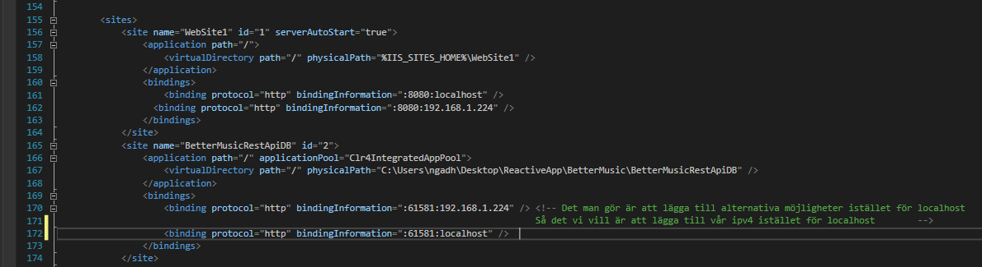

For future development of the project, I will be using .net Core instead of framework. Since there is a lot of more functionality and support for core than framework regarding APIs.

### Other api’s

I have stored my images through the website [*https://imgur.com/*](https://imgur.com/) and used music from *https://www.mboxdrive.com/.* Reason for this will be explained in the next part.

### react native

The frontend is made with React native and here as well, there is nothing out of the ordinary.

At the finish product, I have chosen not to be storing most of the images and music within the app itself, which I did in the beginning. This is due to the lack of dynamic use of react native. Using files must use the “require” function for e.g on images. This causes a *promise* to be made to and is therefore a static function. Which means that there cannot be any dynamic usage of require, and therefor using objects for different artist with different images, will not work on my application. There are workarounds which are bad-practice and therefore not implemented.

Instead I’m using Imgur.com and store the image link in my database, and use the property URI as source for images in the react code.

The hardware I use on my application are both local storage and speakers.

For local storage

I use Async Storage which is an unencrypted, asynchronous, persistent, key-value storage system that is global to the app. When the user logs in and his account is accepted, a *LoginToken* is locally stored on the phone. What this token does is that if the user shuts down the application and reopens it, the users does not have to login again since the user already has been authenticated by the token.

Expo Audio player

For the Audio Player I use the unbuild Audio library which comes with expo. I have combined this and library for the slider to work together so that the user can slide and start wherever he wants on the song.

# Flowchart

Here is an image displaying the flow of my application. There are two alternatives, one if the user already has logged in and another if has not. 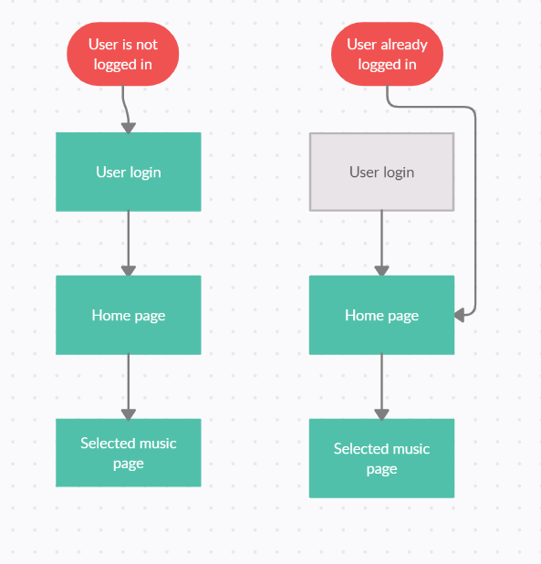

# Discuss why you have chosen a particular navigation pattern

Now the reason behind this navigation pattern is straight forward, for this version I was very ambitious and went more for design rather than having wide range of pages and more advance functionality. I also want it for the user to be simple, that it should not take long for a user from logged in to playing a music. Which is related to User Story nr 7. Once the application is loaded, it should be quickly and simple to play music, therefore there is a short navigation pattern.

Ultimately, the future the navigation pattern would look more like this. Note that the grey boxes are what to be implemented in the future. With this Navigation pattern design, is it still possible for the *Runner* to achieve his goal by playing music quickly after starting the application, since there is no additional steps.

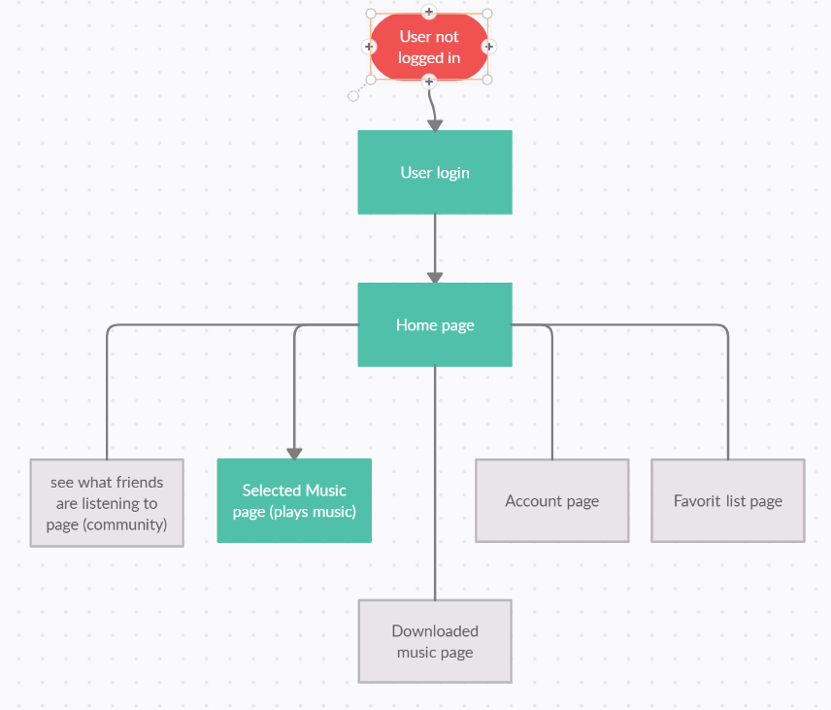

# Explain your graphic design, how you reason about colors and why you selected a particular design

Fort and utmost, my design takes its origin purely from design principals and standard similar design compared to other music applications, such as Spotify. Note also that the images presented in these sections are the design they were intended to look like, due too some restrictions from react native, they look a little different. The images from the app are presented further below.

Throughout the application, the choice of colors is those with high vibrance, to give life to the page and interaction. Most of the colors comes in contrast with the background or the surrounding, that is to make the elements pop and come to life, to give music a livelier experience.

Login page

On the login page I have been careful with the balance of the different objects presented on the login page so that the balance is not disrupted. Having items of equal weight on either side of a center line.

Here, the design principle visual hierarchy was used. By using the design principal proximity, we place all design elements as a relevant connection to each other, close to each other. For that reason, we have Username and Password close and Login and signup. The Music albums are close to each other and the logo, together with branding name are close to each other. (Mårtensson & Olofsson,2017)

Whitespace is also used, its to ensure that all surfaces are covered in a neat way so that there are no gaps that interfere with symmetry and design. Lastly, focal point has been on the login page, this by the user login area larger than the rest of the design, which creates a focus for the user and simplifies it for him where to look and interact. This goes hand in hand with what Steve krug means in his book *Don’t make me think,* to ensure that the user can as simple as possible navigate through applications. there should not be any question marks for the user, and best way of doing this is a good usability. (Mårtensson & Olofsson,2017)



Home page

On the homepage, I’ve used the design principal Harmoney and it’s to ensure that all elements that are to be grouped in the same way but that it also allows a certain variation in its design, this to ensure that the design does not become too monogenic and instead continues to interest the user to look through. This is done by the Artist have a more of a oval shape of the images and the albums more of square.

Grouping and proximity are used to group all relevant parts together, for example the artists are being grouped separately with a header Title that states *“Top Artist of this week”,* below that are the Albums which differentiates from the Artist by being Squares instead of oval shape. And lastly, the lists are as well in another shape and form than the rest, this is to differentiate these elements from the rest, by still being relevant to itself and the rest of the list. (Mårtensson & Olofsson, 2017)



Login page

Proximity, grouping, whitespace and Pattern are used here.

Pattern is an organized repetition of elements that are the same or very similar. Pattern is used here for the user to be able to see from the Home page when the user selects an artist or/and album that the same image comes up again.



# Images – From the app emulator

These are images straight from the application. Note that these vary alittle from the original design. But the same design principals are applied here.

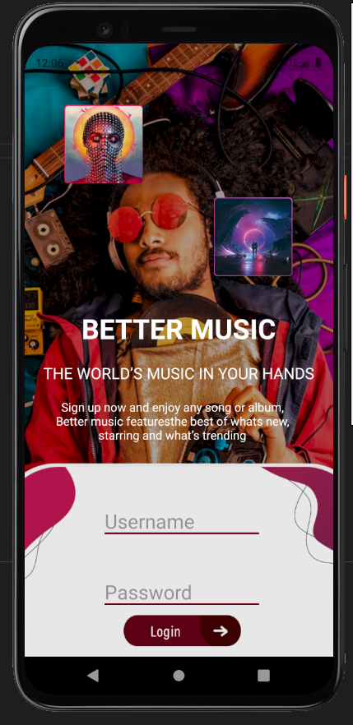

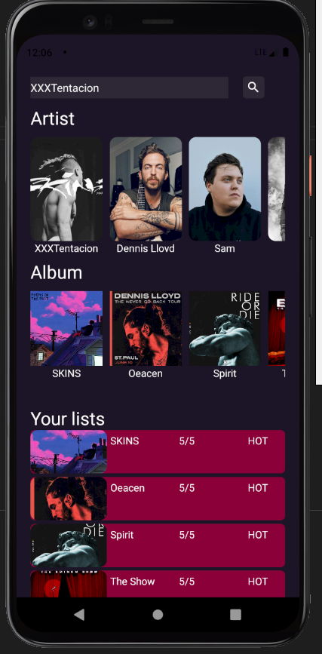

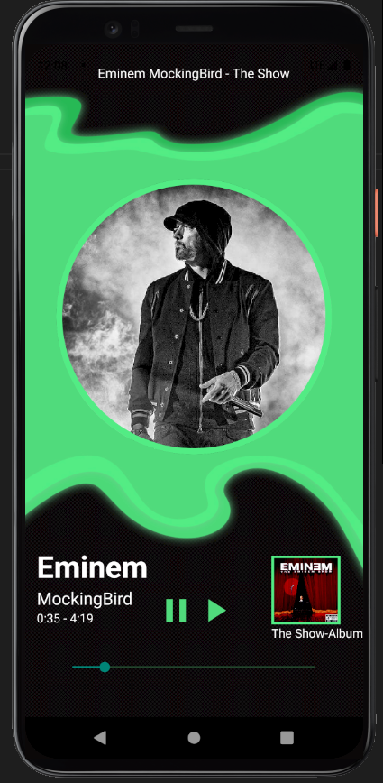

# SQL Database - script

The SQL database script will be added on a seperet file in this folder. There are two script files in this folder, one that should automaticlity fill the database. If that does not work, you have all the data and database sctructure in “Script SQL server and data.txt” and you have to manually create a new database and pase this script in.

# Refrences

Mårtensson, H. & Olofsson, V. (2017). Användbara designprinciper : en systematisk litteraturstudie. (Uppsatsarbete, 15 p., 2016 Handelsgögskolan - Informatik) Örebro: Örebro universitet. [Elektronisk]. Tillgänglig: http://oru.diva-portal.org/smash/get/diva2:1087268/FULLTEXT01.pdf [2021-01-05]

Krug, S. (2013). Don’t make me think, Revisited: A common Sense Approch toWeb and Mobile Usability. 3rd ed. New Riders Publishing

Padron-McCarthy, T. & Risch, T. (2018). Databasteknik. Enskede: TPB